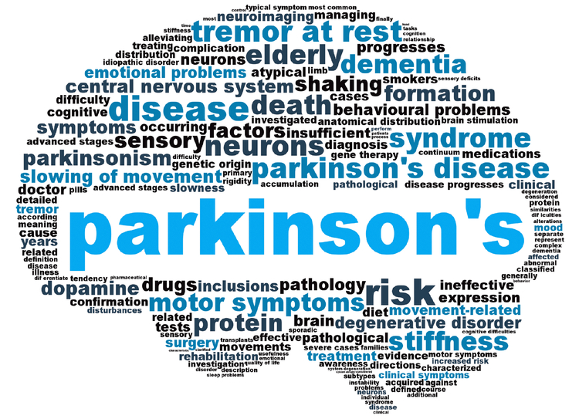

Parkinson’s Disease Support Group
This group is intended for those who are diagnosed with Parkinson’s Disease along with their care partner. The goals for this group are to provide support, educate one another on resources, form connections, and receive educational information. We will meet over Zoom on the fourth Tuesday of each month from 11:00A.M- 12:00P.M. Central Time. This group is free of charge and the meeting dates are posted below.

These dates include:
- July 26th
- August 23rd
- September 27th
- October 25th
- November 22nd
- December 27th

Please contact Nicole Reidy through email at Nicole.reidy@uchospitals.edu or through phone call at 1-773-834-1688 to sign up or for any questions.

